
The Defence Cyber Protection Partnership (DCPP)
and the Cyber Security Model
To become a Defence supplier to MOD you need to
meet the controls as set out in Def Stan 05-138 by
the contract start date. This is done through the
Supplier Assurance Questionnaire (SAQ).
Cyber
Implementation
Plan (CIP)
Suppliers not meeting the controls at the bidding
phase are still able to compete, but will be required
to complete a Cyber Implementation Plan (CIP).
A guide to when a supplier / bidder has
not met all the controls required on the
Supplier Assurance Questionnaire (SAQ)
For example, if you completed a SAQ and do not
have Cyber Essentials or Cyber Essential Plus, you
can use the CIP to commit to having this certification
in place by contract start date as well as submitting
appropriate and accepted mitigation whilst you are
awaiting accreditation.
Edition: 20th December 2022


What is the Cyber Implementation Plan?
The CIP allows a Supplier to propose mitigations
where they have not demonstrated compliance with
MOD’s cyber security requirements as detailed within
the Cyber Risk Profile. The CIP is a contractually
binding document.
Cyber
Implementation
Plan
Is there a CIP Template?
Yes. This will be referenced at the end of this guide.
What?
Remind me - What is the Cyber Security Model?
It’s a risk-based proportionate approach, to protect
MOD Identifiable Information (MODII) on supplier
systems. Visit the DCPP web page.


When do I start the CIP?
After the SAQ has been submitted and a response
returned indicating that not all the controls were met.
Cyber
Implementation
Plan
When do I submit the CIP?
Unless otherwise informed by the Delivery team, the
CIP must be submitted with the tender.
When?
The following slides explain how to complete a CIP
and how it is evaluated.
Ministry
of Defence

Cyber Implementation  Plan  What should I include? | The Cyber Implementation Plan should include risk mitigation actions related to only those controls not met within the Supplier Assurance Questionnaire.



Contents
CIP options against controls Slides 6 to 11
Evaluating s CIP……………………………Slides 12 to 13
CIP Templates (references) Slides 14


- The Supplier commits to meeting the controls by contract start date.
What are my
options with a CIP?
- The Supplier commits to meeting the controls during the contract.
- The Supplier demonstrates an
alternative certification is sufficient.
For any control that hasn’t been met, there are five pre-defined options
- The Supplier will be using another organisation’s network.
- [Least preferred]
This control will not be met.


A supplier can commit to meeting the control(s) by the contract
start date. They should state this intention, along with any
projected dates, activities already taken, and any relevant
certifications currently or previously held.
The Delivery Team should regularly monitor progress and add a
milestone payment condition to the contract.
1. Committing to
meet the controls by
contract start date
Additional: VL01 – Cyber Essentials
IASME’s [free] Cyber Essentials Readiness Tool is a good way to demonstrate you have considered what is required to get Cyber Essentials certification (VL01). It is also a useful exercise for an organisation considering how to improve their cyber security.
CIP Options in detail
Below are links to Cyber Resilience Centres who can give free
advice and actively support Cyber Essentials and the NCSC Cyber Toolkit.
England and Wales
Scotland
Northern Ireland


A supplier can commit to meeting the control at a point
during the contract.
2. Committing to
meet the controls
during the contract
This is similar to meeting the controls by contract start
date but recognises that a control won’t be ready when
required.
This option is likely to be used if the contract start date is
too close and there is sufficient duration.
CIP Options in detail
The Delivery Team will need to consider if additional
mitigations are required until the control is
implemented. E.g. changing how information is
exchanged.
The Delivery Team should regularly monitor progress
and add a milestone payment condition to the contract.


This option is only for:
- VL01 – Cyber Essentials
- L09 – Cyber Essentials Plus
It is not acceptable to say that Certificate ‘X’ is equivalent to
Cyber Essentials (PPN 09/14, para 4). The supplier must
demonstrate the controls required for Cyber Essentials have
been implemented, whilst assuming the Delivery Team is
unaware of the alternative certification.
3. Demonstrate an
alternative
certification meets
the requirements
The original guidance required a paragraph against each control.
This has now been revised as follows:
CIP Options in detail
Cyber Essentials:
Complete the CE Online Readiness tool and submit the output confirming the scope applies to the entire network. Add additional information on a separate page if clarification is needed.
Cyber Essentials Plus (beyond CE)
Confirm that a professional independent third party has carried
out the checks as set out in the Cyber Essentials Plus Test
Specification.


This option allows a supplier to explain that they will be
using another organisation’s network. This network
should have an appropriate level of accreditation. There
also needs to be clarification of the scope, e.g. all MODII
associated with the contract, or a specified sub set.
Example 1
The supplier will be issued with MODNET laptops which
will be used for all MODII associated with that contract.
4. The Supplier will
be using another
organisation’s
network
CIP Options in detail
Example 2
The supplier will be using a sub-contractor’s network
that has UK MOD accreditation of at least SECRET. This
will be for all work involving this level of classification.
The flow down Risk Assessment Reference (RAR) and
sub-contractor’s SAQ reference are provided. The latter
references the accredited system.
Example 3
The supplier will be using the prime’s network which has
been accredited to SECRET. This will be for all work
involving this level of classification. The prime’s SAQ is
provided, referencing the accredited system.


5. [Least preferred]
This control will
not be met.
This option acknowledges that the Supplier will not meet
this control. A better CIP will give details about what is
done, even though it might not meet the required
standard. The intention is to provide the information
necessary to give the project team options to manage
the risk.
CIP Options in detail


When evaluating a CIP the following should be
considered by the assessor:
Evaluating a CIP
- Contract start date
- Contract end date / duration
- The MODII being provided to the supplier versus MODII generated by the supplier
- Worst case scenario if a hostile nation hacked into
the supplier
- Alternative mitigations:
- Can [higher risk] data be withheld (electronically) until security is implemented?
- Can the supplier be provided with a MODNET or SCI laptop?
- Can non-electronic copies be provided instead?
- The CIP is intended to be part of a conversation, not the final word.
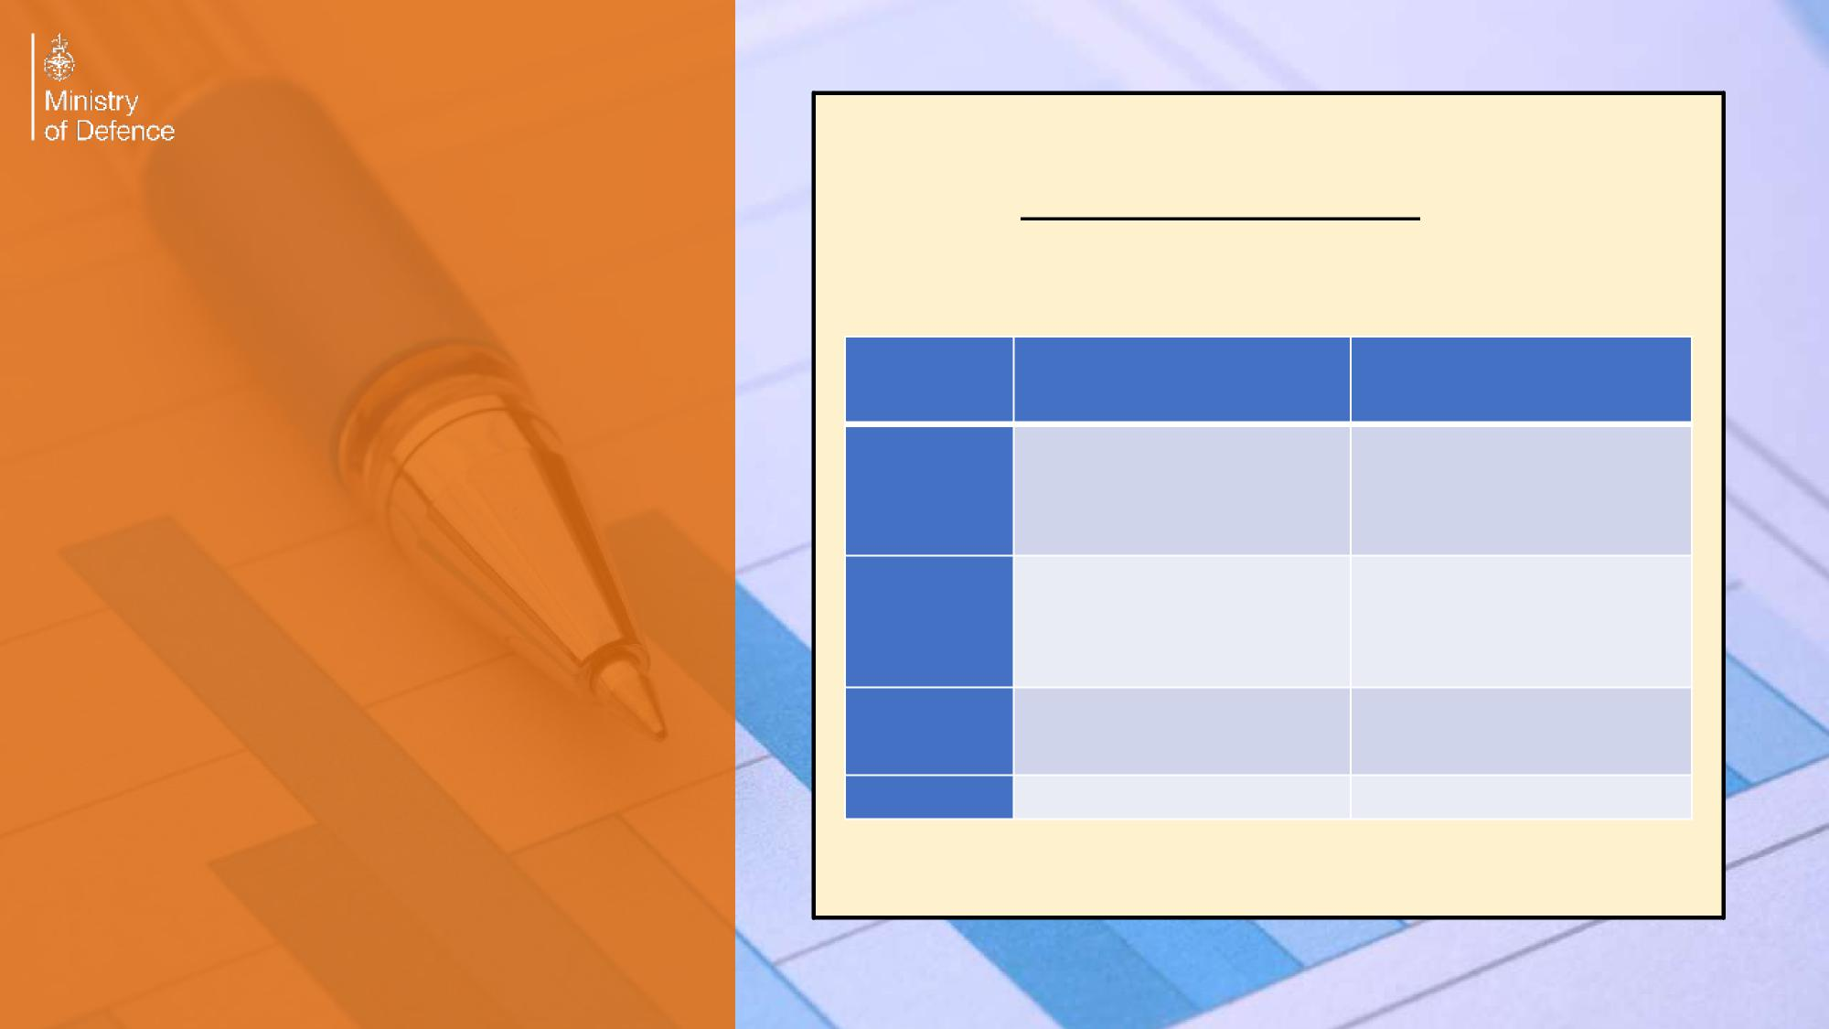

The table below is a summary from the Buyer Supplier guide and is due to be updated shortly.
Evaluating a CIP
Cyber Risk Profile | Risk Acceptor | Informed of risk acceptance
Very Low | The Authority, MOD contract SRO or higher tier supplier | Major business unit / front line command SIRO
Low | The Authority, MOD contract SRO or higher tier supplier | Major business unit / front line command SIRO
Moderate | TLB Accreditor / Principal Security Advisor (PSyA) | Major business unit / front line command SIRO
High | MOD Assessor | MOD SIRO

CIP Templates
- We are currently trialling a template for
- Very Low / Low; and
- Moderate / High
(we will be providing templates for specific Cyber Risk Profiles in early 2023)

- Main delivery is via SAQ response email as an attachment. These will be available via our web page in early 2023.

